WRITEUP IT FESTIVAL 2023



AJARIN DONG PUH SEPUH

CHRISTOPHER RALIN ANGGOMAN

FIKRI MUHAMMAD ABDILLAH

RUBEN ALBION YOBEL

**Daftar Isi**

REVERSE ENGINEERING 3

Into The Maze 3

CRYPTOGRAPHY 10

calculus 10

Not So Old School 12

# REVERSE ENGINEERING

## Into The Maze

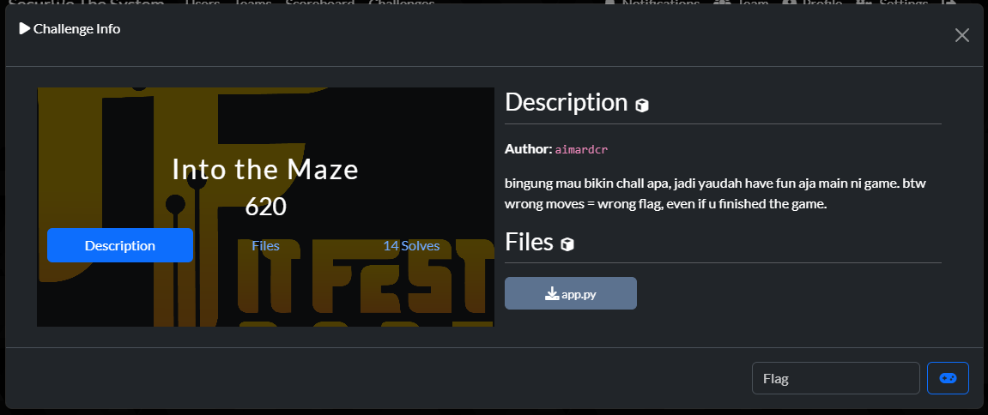

Kami mendapat file `app.py` yang isinya adalah sebuah game labirin (maze).

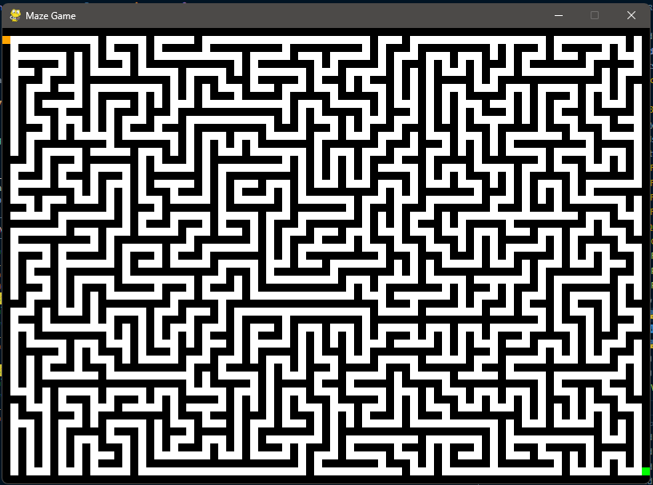

Dalam game tersebut kita akan disuruh untuk mencapai kotak hijau untuk mendapatkan flag, namun ketika mencapai kotak hijau, langkah tidak boleh salah dan harus mendapatkan rute terdekat, karena itu kami memodifikasi game asli agar bisa mendapatkan rute paling dekat, dan otomatis akan berjalan

Berikut modifikasi code kami:

|  |
| --- |
| import pygame import sys  import hashlib from Crypto.Cipher import AES from Crypto.Util.Padding import pad, unpad  FLAG = '0e0d9bc536bff99d227b6b26470de14d1784426798126874fb86f35144fac472e8cb8aa1ec3243490706840421a5aa6c00824ef69048cb1a422bdb70c0157530'  class **HackedGame**:  def **__init__**(self, width, height, maze_layout):  self.width = width  self.height = height  self.screen = pygame.display.set_mode((width, height))  pygame.display.set_caption("Maze Game")  self.maze = Maze(maze_layout, width, height)  self.player = Player(self.maze.cell_size)  self.finded_route = self.find_route()  self.key_solve = self.convert_route_to_moves(self.finded_route)  self.is_winned = False   def **is_win**(self):  return self.player.x >= self.width - self.maze.cell_size and self.player.y >= self.height - (self.maze.cell_size * 2)    def **get_possible_moves**(self, pos):  sys.setrecursionlimit(100000)  x, y = pos  moves = []  if x > 0 and self.maze.layout[y][x - 1] == 0:  moves.append((x - 1, y))  if x < len(self.maze.layout[0]) - 1 and self.maze.layout[y][x + 1] == 0:  moves.append((x + 1, y))  if y > 0 and self.maze.layout[y - 1][x] == 0:  moves.append((x, y - 1))  if y < len(self.maze.layout) - 1 and self.maze.layout[y + 1][x] == 0:  moves.append((x, y + 1))   return moves    def **find_route**(self, pos=(0, 1), route=[]):  if pos[0] == len(self.maze.layout[0]) - 1 or pos[1] == len(self.maze.layout) - 1:  return route   for move in self.get_possible_moves(pos):  if move not in route:  route.append(move)  if self.find_route(move, route):  return route  route.pop()   return False   def **convert_route_to_moves**(self, route):  moves = []  x1, y1 = (0, 1)  for i in range(len(route)):  x2, y2 = route[i]   if x1 == x2:  if y1 < y2:  moves.append(pygame.K_DOWN)  else:  moves.append(pygame.K_UP)  else:  if x1 < x2:  moves.append(pygame.K_RIGHT)  else:  moves.append(pygame.K_LEFT)  x1, y1 = x2, y2   return moves    def **str_moves**(self, moves):  res = []  for m in moves:  if m == pygame.K_DOWN:  res.append("DOWN")  elif m == pygame.K_UP:  res.append("UP")  elif m == pygame.K_LEFT:  res.append("LEFT")  elif m == pygame.K_RIGHT:  res.append("RIGHT")  return res   def **run**(self):  running = True  while running:  event = pygame.event.get()  while event or self.key_solve:  if event:  evt = event.pop(0)  if evt.type == pygame.QUIT:  running = False  elif evt.type == pygame.KEYDOWN:  self.player.move(evt.key, self.maze)  if self.key_solve:  self.player.move(self.key_solve.pop(0), self.maze)   if not self.is_winned and self.is_win():  key = hashlib.md5(str(self.player.state).encode()).digest()  iv = hashlib.md5(str(self.player.x).encode() + str(self.player.y).encode() + str(self.player.move_count).encode()).digest()   try:  cipher = AES.new(key, AES.MODE_CBC, iv)  flag = unpad(cipher.decrypt(bytes.fromhex(FLAG)), AES.block_size).decode()   print(flag)  self.is_winned = True  except:  print("Invalid moves!")  running = False  break   self.screen.fill(WHITE)  self.maze.draw(self.screen)  self.player.draw(self.screen)  pygame.display.flip()   pygame.quit()  sys.exit()  class **Maze**:  def **__init__**(self, layout, width, height):  self.CELL_COLOR = {  0: WHITE,  1: BLACK,  2: YELLOW  }  self.layout = layout  self.cell_size = 10   def **draw**(self, screen):  for y, row in enumerate(self.layout):  for x, cell in enumerate(row):  rect = pygame.Rect(x * self.cell_size, y * self.cell_size, self.cell_size, self.cell_size)  color = self.CELL_COLOR[cell]  pygame.draw.rect(screen, color, rect)   pygame.draw.rect(screen, RED, (0, self.cell_size, self.cell_size, self.cell_size))  pygame.draw.rect(screen, GREEN, (len(self.layout[0]) * self.cell_size - self.cell_size, len(self.layout) * self.cell_size - (self.cell_size * 2), self.cell_size, self.cell_size))   def **is_valid_move**(self, x, y):  if x < 0 or y < 0 or x >= len(self.layout[0]) * self.cell_size or y >= len(self.layout) * self.cell_size:  return False  return self.layout[y // self.cell_size][x // self.cell_size] in [0, 2]  class **Player**:  def **__init__**(self, size):  self.x = 0  self.y = size  self.size = size  self.speed = size  self.state = [0] * 32  self.state_pos = 0  self.move_count = 0   def **move**(self, key, maze):  if key == pygame.K_LEFT:  new_x = self.x - self.speed  if maze.is_valid_move(new_x, self.y):  maze.layout[self.y // self.size][self.x // self.size] = 2  self.x = new_x   self.state_pos -= 1  if self.state_pos < 0:  self.state_pos = 0   elif key == pygame.K_RIGHT:  new_x = self.x + self.speed  if maze.is_valid_move(new_x, self.y):  maze.layout[self.y // self.size][self.x // self.size] = 2  self.x = new_x   self.state_pos += 1  if self.state_pos >= len(self.state):  self.state_pos = len(self.state) - 1  elif key == pygame.K_UP:  new_y = self.y - self.speed  if maze.is_valid_move(self.x, new_y):  maze.layout[self.y // self.size][self.x // self.size] = 2  self.y = new_y   self.state[self.state_pos] = 1  elif key == pygame.K_DOWN:  new_y = self.y + self.speed  if maze.is_valid_move(self.x, new_y):  maze.layout[self.y // self.size][self.x // self.size] = 2  self.y = new_y   self.state[self.state_pos] = 0   self.move_count += 1   def **draw**(self, screen):  pygame.draw.rect(screen, ORANGE, (self.x, self.y, self.size, self.size))  pygame.init()  WHITE = (255, 255, 255) BLACK = (0, 0, 0) ORANGE = (255, 165, 0) GREEN = (0, 255, 0) RED = (255, 0, 0) YELLOW = (255, 255, 0)  MAZE_LAYOUT = . . .  WIDTH, HEIGHT = 810, 570  game = HackedGame(WIDTH, HEIGHT, MAZE_LAYOUT) game.run() |

Setelah kami run program tersebut, kami pun mendapat flag nya:

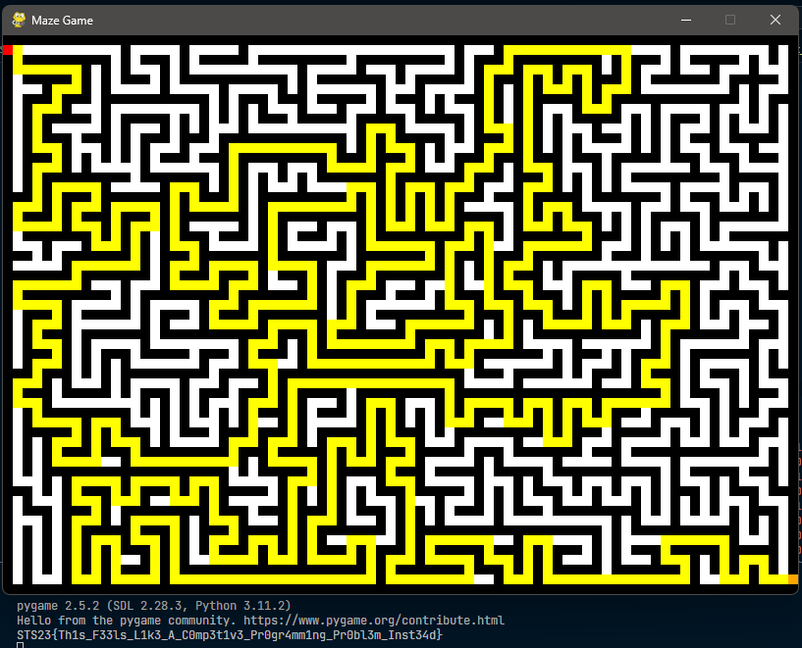

**FLAG:** STS23{Th1s_F33ls_L1k3_A_C0mp3t1v3_Pr0gr4mm1ng_Pr0bl3m_Inst34d}

# CRYPTOGRAPHY

## calculus

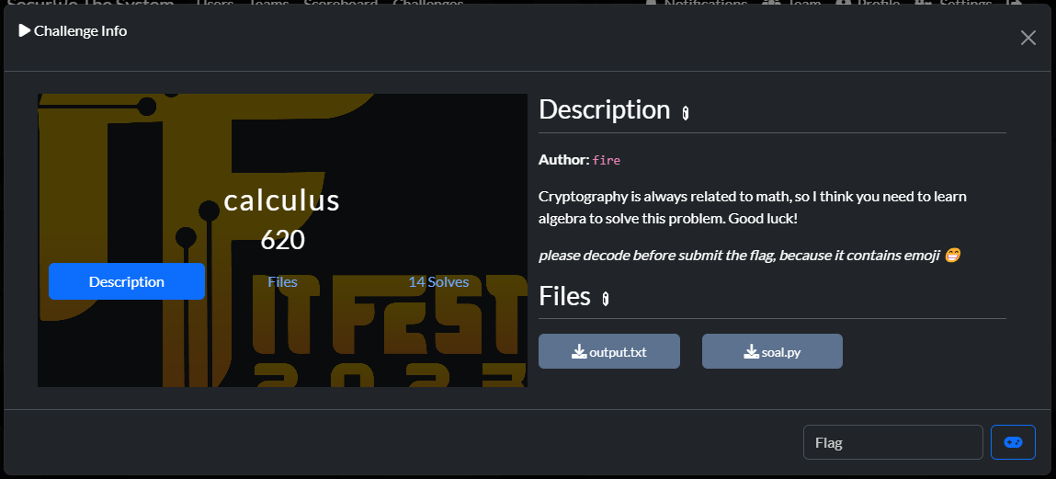

Kami medapat 2 file `soal.py` & `output.txt`, dalam soal flag akan di masukkan ke dalam fungsi encrypt, dan hasil tersebut akan di taruh pada file `output.txt`.

Dalam fungsi encrypt, sebuah set di generate dengan isi 2 bilangan prima dengan besar 1024 bit, selanjutnya variable p akan di generate dengan bilangan prima dengan besar sama, yaitu 1024 bit. n dihasilkan dengan constant variable yaitu `2^3+2^4` dengan hasil `24`. selanjutnya 3 variabel akan dihasilkan (x, y z) seperti notasi di bawah ini:



selanjutnya cipher dihasilkan dengan notasi di bawah ini:



selanjutnya (x, z, c) akan dikembalikan (return).

Dengan penjelasan di atas, maka tujuan pertama adalah untuk mendapatkan nilai dalam set ini. Disini jika kita mengetahui hasil perkalian (mul) dari set kita dapat menggunakan rumus ‘quadratic formula’ seperti di bawah ini

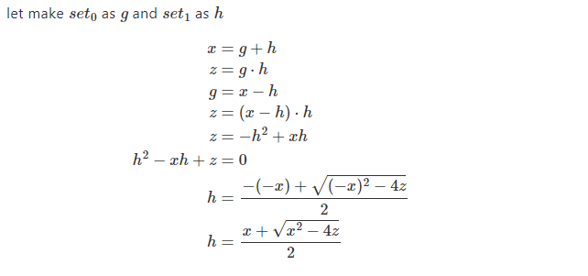

karena `z` diatas telah di tambah oleh `k`, kita harus mendapatkan nilai k, dan mengurangi z dengan k, lalu menggunakan formula diatas. karena `k` bernilai sangat kecil (0~23) kita dapat bruteforce nilai tersebut

berikut adalah kode solvernya:

|  |
| --- |
| from Crypto.Util.number import * from decimal import Decimal, getcontext getcontext().prec = 1000  def **formula**(x, z):  return round((x + (Decimal(x**2 - 4*z).sqrt())) / 2)  x = . . . z_p_k = . . . c = . . . c = int(c, 16)  for i in range(pow(2,3) + pow(2,4)):  z = z_p_k - i  p1 = formula(x, z)  p2 = x - p1  if p1 * p2 + i != z_p_k:  continue  y = pow(p1, 2) + pow(p2, 2)  m = (c // (x + y))  assert m * (x + y) == c  m ^= (p1**3 + p2**3)  print(long_to_bytes(m)) |



**FLAG:** STS23{kalo_kamu_pake_z3_kamu_curang_woi_🗿🗿🗿}

## Not So Old School

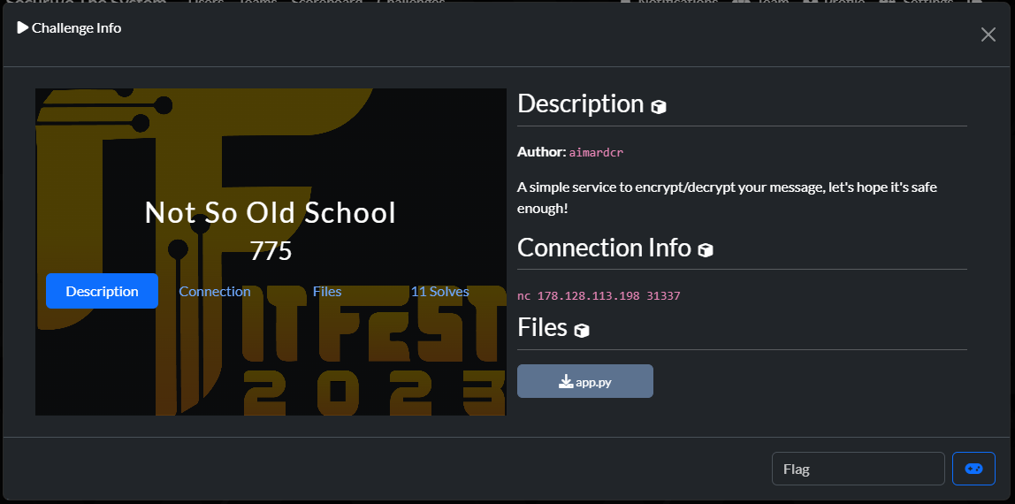

Kami diberikan file `app.py` yang merupakan source code dari netcat server, dalam fungsi utama kita dapat memilih 3 pilihan pada menu (“Get Encrypted Flag”, “Encrypt String”, dan ”Exit”). Program di awal generate key dengan cara random sepanjang 8 byte. key akan digunakan saat encrypt message (flag, input string). di dalam fungsi encrypt terlihat program sangat membingungkan untuk reversing key nya, namun saat diteliti, sebenarnya plaintext hanya di xor secara sederhana dengan `generated_xor_key` yang telah di generate menggunakan key asli, lalu hasil xor akan di gunakan untuk mendapatkan index sbox. dengan begitu kita hanya perlu mendapatkan index sbox dari cipher yang telah di generate dan menggunakan notasi di bawah ini:

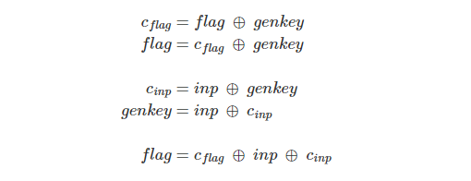

berikut adalah solver nya:

|  |
| --- |
| from pwn import *  sbox = [98, 56, 7, 192, 121, 149, 107, 246, 120, 132, 191, 152, 229, 238, 94, 106, 176, 170, 161, 253, 145, 181, 237, 211, 219, 250, 131, 190, 158, 24, 126, 32, 79, 212, 244, 53, 60, 183, 83, 128, 162, 137, 15, 148, 50, 51, 166, 92, 171, 88, 44, 242, 69, 91, 101, 103, 175, 3, 82, 40, 245, 110, 34, 143, 248, 35, 109, 115, 227, 47, 140, 122, 193, 59, 39, 243, 208, 55, 165, 213, 224, 231, 96, 185, 151, 100, 105, 12, 66, 42, 160, 214, 205, 189, 130, 5, 147, 20, 236, 85, 142, 194, 2, 228, 124, 215, 14, 26, 240, 223, 154, 203, 54, 25, 141, 200, 8, 111, 177, 0, 75, 73, 204, 80, 230, 58, 112, 10, 52, 157, 116, 41, 4, 217, 18, 9, 174, 27, 226, 163, 36, 13, 167, 72, 241, 21, 186, 30, 87, 221, 168, 89, 239, 29, 178, 179, 249, 45, 195, 57, 95, 22, 180, 153, 129, 108, 201, 202, 63, 68, 64, 135, 207, 156, 133, 220, 11, 71, 6, 233, 232, 119, 173, 90, 102, 117, 136, 86, 247, 76, 234, 164, 172, 184, 78, 225, 125, 199, 46, 210, 216, 123, 31, 235, 182, 251, 38, 206, 139, 197, 159, 127, 150, 61, 16, 19, 28, 198, 93, 77, 49, 169, 1, 114, 134, 187, 188, 67, 113, 74, 218, 104, 254, 65, 196, 155, 144, 209, 37, 81, 70, 48, 43, 84, 138, 62, 17, 23, 222, 118, 146, 33, 99, 252, 97]  # nc 178.128.113.198 31337 HOST = "178.128.113.198" POST = 31337 io = remote(HOST, POST)  def **encrypt**(s: bytes):  io.sendlineafter(b"> ", b"2")  io.sendlineafter(b": ", s)  return io.recvline().strip()  def **get_encrypted_flag**():  io.sendlineafter(b"> ", b"1")  return io.recvline().strip()  def **get_index**(sbox, vals):  res = []  for val in vals:  for i in range(len(sbox)):  if sbox[i] == val:  res.append(i)  break  return res  def **check_valid_hex**(s):  for c in s:  if c not in b"0123456789abcdef":  return False  return True  def **main**():  global io  while True:  print("Getting encrypted flag...")  enc_flag = get_encrypted_flag()  if not check_valid_hex(enc_flag):  print("Invalid hex, reconnecting...")  io.close()  io = remote(HOST, POST)  continue  print("Got encrypted flag!")  enc_flag = get_index(sbox, bytes.fromhex(enc_flag.decode()))  break  inp = b"0" * len(enc_flag)  enc_inp = get_index(sbox, bytes.fromhex(encrypt(inp).decode()))  flag = xor(enc_flag, inp, enc_inp).decode()  print(flag)  main() |

berikut hasilnya:

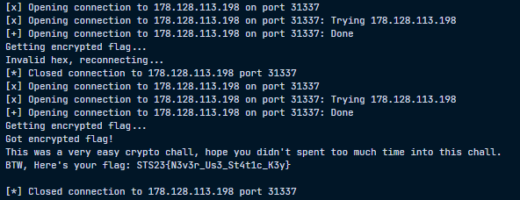

**FLAG:** STS23{N3v3r_Us3_St4t1c_K3y}